Studying technology roadmapping development and selecting the appropriate model for aircraft design and manufacturing industry
Hamid Abdoli Aghaei
Mohammad Ali Beheshtinia
Mohammad Sadegh Amalnick
Majid Gholimotlagh

Abstract
Roadmap is a foresight tool, and its goal and application is for decreasing the risk of investment. it is important especially in macro and long term investments. On the other hand, the extent and complexity of aircraft design and manufacturing industry cause the need for roadmapping. Roadmapping requires an appropriate model, then in this research by using Modified Digital Logic (MDL) and experts viewpoints, the appropriate roadmap model for developing aircraft design and manufacturing industry is presented. Results show the appropriate approach, frame work and method, are respectively, Combinational, Multiple Layers and T-Plan.

Key words: Roadmap; Technology roadmap; Aircraft design; Strategy planning; T-Plan.

1. Introduction
Achieving advanced technologies, is a part of strategic plans in developed and developing countries, while aviation industry is an important issue in industrial development. The following figure shows the position of strategic plan of aviation industry in the national development strategic plan.
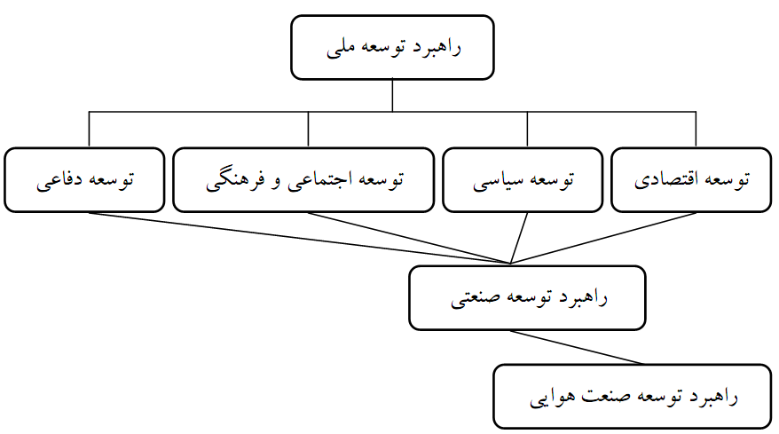
National Development plan
National Development Strategy
Development Strategy of Aviation Industry
Social and Cultural Development
Economical Development
Political Development
Defense Development
Fig. 1. The hierarchy of strategies and the position of aviation industry development strategy

According to the definition, this industry includes:
- Design and Construction Industry
- Repair and maintenance industry
- Aviation industry (services)
Requiring a large investment in aircraft design and construction industry, and also the existence of many strong competitors in this industry, prevents policymakers and investors from getting enter to this sector. This is proved by the Bankruptcies [1].
According to the material, using advanced tools such as foresight tools which are for creating a favorable, not a desired future, are needed and technology roadmap is one of these tools, that draws the path from current situation to the destination and aligns the investment with goals. Deciding to develop a roadmap, an organization should first determine the approach, framework and methodology.
The remainder of the paper is organized as follows. After describing the technology roadmap approaches, frameworks and methods in detail, a review of literature is presented in Section 2. Section 3 presents the research method and obtained results. Finally, Section 4 concludes the paper.

2. Literature Review
In this section a review of researches in technology roadmap scope is presented.
2.1. Roadmapping approaches
Two fundamental roadmapping approaches are expert-based and computer-based. In expert-based approach, a team of experts is convened to identify and develop attributes for the nodes and links of the roadmap. For an organization in which many of the roadmap components are being pursued in-house, such as a large focused government or corporate laboratory, much of the expertise can be assembled in-house. Researchers, developers, marketers and others with relevant knowledge of the overall roadmap theme can be readily convened to develop the framework. At the other extreme, organizations with little expertise in the overall roadmap theme, such as venture capital groups or cash-rich organizations that wish to expand their boundaries, will require external assistance to develop credible roadmaps.
In computer-based approach, large textual databases that describe science, technology, engineering, and end products are subject to computer analyses. These databases could include published papers, reports, memoranda, letters, etc. Through the use of generic computerized methodologies, including computational linguistics and citation analyses, research, technology, engineering, and product areas are identified; their relative importance is estimated and quantified and their relationships and linkages to other areas are identified and quantified. Once all these node and link attributes have been specified, the network is then constructed.
Another possible limitation of the computer-based approach has to do with the absence of interaction among experts that is vital to the roadmapping process. As such, a balanced combination of the expert-based and computer-based approaches may prove to be the most effective and efficient approach to roadmap construction. In sum, both expert-based and computer-based approaches have value to offer, and the best features of each should be identified, extracted, and employed for optimal results [2].
The properties of mentioned approaches are summarized in Table 1.

Table 1. Approaches of roadmapping and their properties
property | Approach
Based on the knowledge and experience of experts | Expert-based
Based on Databases | Computer-based
- Based on the existence and experts’ interactions  - Needing more money and time | Combinational

2.2. Roadmap formats
The six typical formats are selected:
- Multiple layers (Fig. 2a): This is the most common format of technology roadmap comprising a number of layers (and sub layers), such as technology, product and market. The roadmap allows the evolution within each layer to be explored, together with the inter layer dependencies, facilitating the integration of technology into products, services and business systems.
- Bars (Fig. 2b): Many roadmaps are expressed in the form of a set of bars, for each layer or sublayer. This has the advantage of simplifying and unifying the required outputs, which facilitates communication, integration of roadmaps, and the development of software to support roadmapping.
- Tables (Fig. 2c): In some cases, entire roadmaps, or layers within the roadmap, are expressed as tables (time vs. performance or requirements). This type of approach is particularly suited to situations where performance can be readily quantified, or if activities are clustered in specific time periods.
- Single layer: This form is a subset of Type A, focusing on a singlelayer of the multiple layer roadmap. While less complexity, the disadvantage of this type is that the linkages between the layers are not generally shown.
- Text: Some roadmaps are entirely or mostly text based, describing the same issues that are included in more conventional graphical roadmaps (which often have text-based reports associated with them) [3].
- Network (Fig. 2d): some roadmaps don’t have time dimension and just show the way from current to the future situation [4].

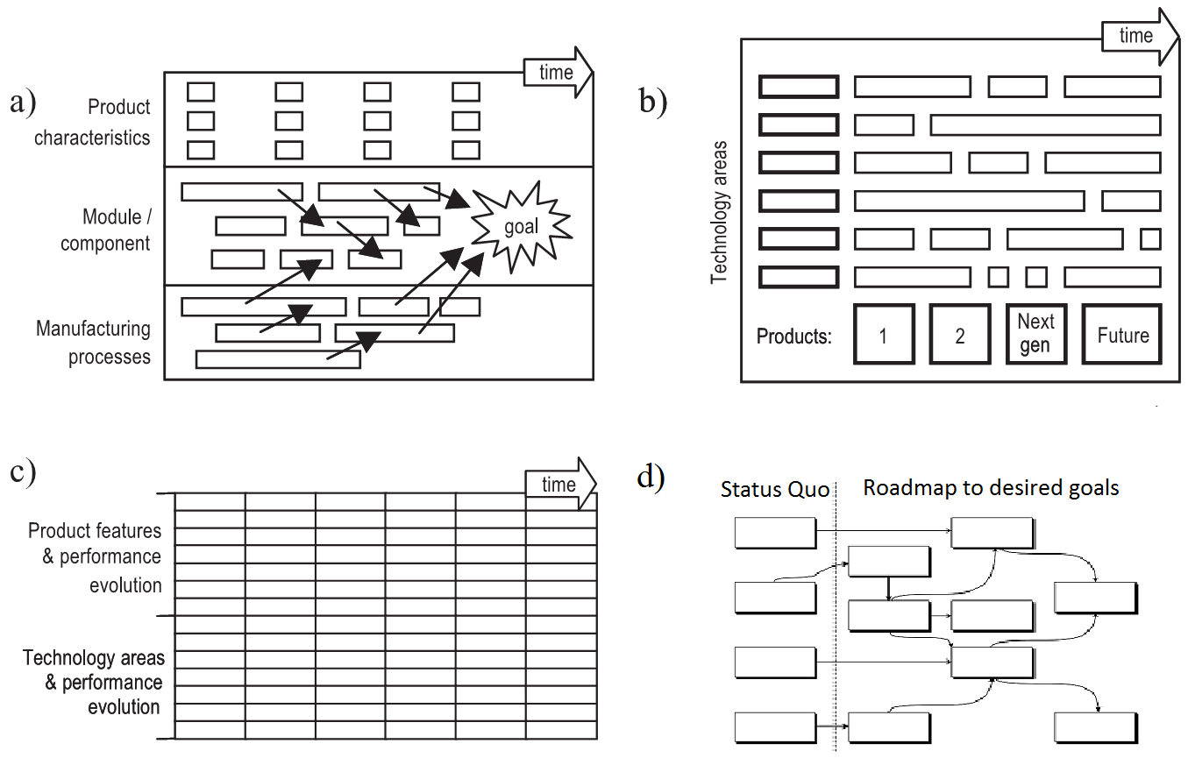
Fig. 2. Roadmap formats: (a) Multiple layers [3] (b) Bars [3] (c) Tables [3] (d) Network [4]

The properties of mentioned frameworks are summarized in Table 2.
Table 2. Frameworks of roadmapping and their properties
framework | Property
Multiple Layers | Advantages:  - The most common form of technology roadmap  - The most flexible form in use  - Facilitating the integrating of technology in products, services and business systems  - Illustrating the impact of technology push and market elasticity  Disadvantages:  - No use in too complex maps
Bars | Advantages:  - Simplify and unify required outputs  - Facilitate supporting software development  Disadvantages:  - Not showing the relations between layers
Tables | Advantages:  - No graphic complexity and easy for use the roadmap  Disadvantages:  - Appropriate for making quantitative performance  - Appropriate for categorizing activities in certain periods  - Not showing the relations between layers  - Not precise in the time dimension because of putting activities in specific time categories
Single Layer | Advantages:  - One Layer of a multilayer map  - Appropriate when the Roadmap is too complicated  Disadvantages:  - Not showing the relations between layers
Text | Advantages:  - Complete describing of Roadmap issues  Disadvantages:  - Difficult for understanding the relationships and the timings relative to other graphic methods.  - No clarity in showing gaps
Network | Advantages:  - Simple for developing  - Needing less time  Disadvantages:  - Not having time dimension but showing primacy-recency and relations

2.3. Roadmapping methods
In this research, six methods are considered as follows: bibliometric-based [2], T-Plan [5] [6] [7], Albright & Kappel [8], Technology Roadmapping Algorithm for New Products (TRANP) [9], COCONET [10] and Garcia & Bray [11] [12]. Some properties of these methods are presented in Table 3.
Table 3. Methods of roadmapping and their properties
Method | property
bibliometric-based | - needing advanced qualitative methods  - based on database  - vast use of computer technology
T-Plan | - used in various industries  - focuses on market and needed products and technologies  - supporting quick start of roadmapping  - quick economic value assessment of method  - workshop-based
Albright & Kappel | - Used in Lucent Technologies for years in telecommunication  - focuses on market and needed products and technologies  - seminar-based
TRANP | - driving factor: new product development  - market development oriented  - for developing technology in corporate  - usually for developing technology and not for industrial producing  - based on qualitative analyses and getting experts’ viewpoints
COCONET | - based on scenario developing  - making relations between industries and research association  - having technology push approach  - workshop-based
Garcia & Bray | - using in corporate and industry level  - product oriented  - comprehensive method  - time consuming

Phaal and Muller in 2009 explore the issues of how to design and architect roadmaps and roadmapping processes, which is crucial if the approach is to provide a framework for supporting effective dialogue and communicationwithin and between organizations [13]. Value Driven Technology Road Mapping process is introduced for integrating decision making and marketing tools by Fenwick et al. [14].
Candido et al. challenges associated to the application of service-oriented architecture into reconﬁgurable supply chains are enumerated and detailed with the aim of providing a roadmap [15].
Suh and Park use patent map for Service-oriented Technology Roadmap for R&D strategy of service industry [16]. Holmstrom et al. outline a roadmap for introducing tracking in businesses operations. Their proposed roadmap circumvents the most challenging business cases for introducing tracking and radio frequency identiﬁcation technology in the supply chain and focuses on asset management as a more accessible route for business [17].
Abe et al. integrate business modeling and roadmapping methods. They propose the framework for revitalization of regional industries by using the strategic technology roadmap made by the Ministry of Economy, Trade and Industry with business modeling [18]. Energy technology roadmap for the next 10 years in Korea are considered by Lee et al. in 2009. The roadmap not only represents a milestone in terms of the development of national energy technology in Korea, but also serves to identify the primary energy technologies which should be developed [19].
The roadmap also supplies energy policymakers with successful R&D alternatives by development of energy technologies under the current Korean energy environment [19]. A roadmap for advanced ceramics for the period from 2010 to 2025 has been developed by Rödel et al. to provide guidelines for future investments for policy makers, scientists and industry [20]. Kim et al. in 2009 develop a technology roadmap for construction R&D through interdisciplinary research efforts [21]. Jakoubi et al. introduce a roadmap for vision of risk-aware business process management that is capable of providing information for economic as well as for security disciplines [22]. Yasunaga et al. depict the governmental agency's objectives, activity details and ways of applications of technology roadmaps and roadmapping [23].
Loureiro et al. in 2010 introduce a technology roadmapping method and its usage in Chemistry. They offer a brief review of this tool, covering the definitions of the terms technology roadmap and technology roadmapping, the types and formats of roadmaps, the structure of roadmaps, the processes of operation/adaptation of roadmapping, challenges and the key successful factors in implementing the roadmapping and its usage [24].
Lee et al. introduce a Bayesian belief network approach to operationalization of multi-scenario technology roadmap [25]. Phaal et al. in 2010 introduce a framework for mapping industrial emergence. Their framework has been tested by developing more than 25 diverse ‘emergence maps’ of historical industrial evolution, building conﬁdence that the framework might be applicable to current and future emergence [26].
Niekerk et al. introduce a process-based assessment framework for technology education that serve as a roadmap to technology teachers, especially those with little or no pedagogical knowledge in technology to assist them to base their assessment on sound methodology [27]. Phaal et al. in 2012 set out a workshop-based approach that comprises functional modules that can be combined to address a range of management challenges [28].
To develop a roadmap, each organization must first select a template to create the framework for the next steps. To the best of our knowledge to date, no published work has dealt with selecting the roadmap formats, approaches and techniques to develop a roadmap in a report together and compare them. In This paper, formats, approaches and methods are extracted and compared together; then, the best model has been specified for the aircraft.

3. Research method
As developing a roadmap, requires experts’ viewpoints, then we first decided to gather data from Aircraft experts by using Delphi method and getting consensus. Questionnaire developed for aircraft experts, who were familiar with roadmap. It contained a summary of frame works, approaches and methods of roadmapping including their properties for comparing them. MDL method for comparing is used. This method is described at the next section. Also, at the end of this questionnaire experts could write down their explanations.
After gathering the questionnaire, summing the marks in the same row gives the parameter’s mark, and the sum of parameter’s marks gives the total mark for parameter. Finally, prioritization is done.
3.1. MDL method
The weighted property method and later on the digital logic methods (DL) have shown to be quite effective for Multi-attribute decision making problem, especially. Basically, in these methods, a certain weight is assigned to each attribute depending on its relative importance to the others. DL uses paired comparison technique. In comparing two attribute, the more preferable attribute is given a numerical value of "1" and the other one is given a value of "0". However, for the modiﬁed digital logic (MDL) method, a value of "3" is assigned to the more preferable attribute and the value of "1" to the other one. In this method, two attributes with equal importance receive equal numerical values of "2". Then the weighting factor α for each property is found by summing up the positive decisions that every property receives divided by the total positive decisions that all the material properties are given. In this way for each material would be obtained [29]. An example of using modiﬁed digital logic method to cryogenic storage tank is presented in Figure 3.
Figure 3- Application of modiﬁed digital logic method to cryogenic storage tank [29]
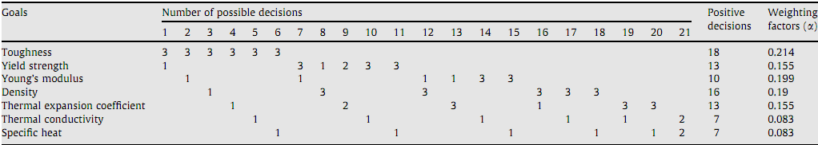
3.2. Results
There was six questionnaire gathered, and the results are shown in table 4,5 and 6.

Table 4: Results of appropriate frame work.
No. of Questionniare  Frame work | 1 | 2 | 3 | 4 | 5 | 6 | Total mark
Multiple Layers | 15 | 14 | 12 | 14 | 10 | 11 | 76
Tables | 8 | 11 | 15 | 10 | 8 | 9 | 61
Network | 8 | 14 | 7 | 8 | 7 | 15 | 59
Single Layer | 13 | 7 | 10 | 6 | 11 | 9 | 56
Bars | 8 | 9 | 11 | 10 | 11 | 7 | 56
Text | 8 | 5 | 5 | 9 | 13 | 9 | 49
For validating of questionnaires, we use a new method, compatibility rate in AHP. Tables which have the maximum mark 15, scaled in 1-9 intervals as shown in Table 4.
Table 5: An example of result converting
 | Multiple Layers | Tables | Network | Single Layer | Bars | Text
Multiple Layers | 1 | 4 | 4 | 1 | 4 | 4
Tables |  | 1 | 1 |  | 1 | 1
Network |  | 1 | 1 |  | 1 | 1
Single Layer | 1 | 3 | 3 | 1 | 3 | 3
Bars |  | 1 | 1 |  | 1 | 1
Text |  | 1 | 1 |  | 1 | 1
Eigen vectors and values are achieved from the equation det(A-λI)=0. In this equation, A is the questionnaire matrix, I is the unit vector, and the λ is the Eigen value. If the maximum value of λ is shown by λ_{max}, CR should be lower than 0.1 and it is calculated by the following equation.
In this equation, n is the number of issue, and RI is 1.24. Using this for the previous table, λ_{max} comes to 6.0092 and CR is 0.0015. As the CR is lower than 0.1 it shows the validity of the table.
Table 6: CR for issues
No. of Questionniare  issues | 1 | 2 | 3 | 4 | 5 | 6
Format | 0.0015 | 0.0195 | 0.0260 | 0.0172 | 0.0103 | 0.0043
Approach | 0.0379 | 0 | 0 | 0.0379 | 0.0379 | 0
Method | 0.0197 | 0.0176 | 0.0153 | 0 | 0.0022 | 0.0151

As the results are lower than Incompatibility rate, then the all are valid and the priorities can be used.
The following conclusions can be achieved from the results:
The framework for roadmap: from the previous explanations and results, the Multiple Layer frame work is the appropriate one. And this result is reasonable. Because in aircraft industry, the market should be taken into attention and producing is not the only important item. Also as the aircraft and its sub systems are complex, then it causes to use Multiple Layer frame work for showing the relations of sources, technology and product and their relations with market.
TableTable 7: Appropriate approach in results
No. of Questionniare  approach | 1 | 2 | 3 | 4 | 5 | 6 | Total mark
Combinational | 4 | 6 | 6 | 2 | 6 | 6 | 30
Expert-based | 6 | 3 | 3 | 6 | 4 | 3 | 25
Computer-based | 2 | 3 | 3 | 4 | 2 | 3 | 17

Approach of roadmapping: the results shows that the combinational approach gets the maximum mark and it was predictable. Because there are so much information about aircraft technologies available , but not only the data base of technologies and other information about aircraft should be studied but also the interaction of experts is needed for covering the shortcomings of computer-based methods. Then using the Combinational approach of computer-based and expert-based is the approach for developing aircraft roadmap. While this approach needs more time and cost, but it is negligible in compared with the total cost of design and construction of aircraft.

Table 8: Appropriate developing method in results
No. of  Questionniare  Developing  Method | 1 | 2 | 3 | 4 | 5 | 6 | Total mark
T-Plan | 15 | 14 | 15 | 13 | 7 | 11 | 75
TRANP | 12 | 8 | 12 | 9 | 13 | 10 | 64
COCONET | 9 | 5 | 9 | 13 | 13 | 14 | 63
Garcia & Bray | 9 | 15 | 11 | 8 | 12 | 5 | 60
bibliometric-based | 5 | 11 | 8 | 8 | 8 | 10 | 50
Albright & Kappel | 10 | 7 | 5 | 8 | 7 | 10 | 47

Roadmap developing method: T-model gets the most mark. it is used in developing so many roadmaps. This method especially is appropriate in developing the first Roadmap for aircraft, because using this method, developing Roadmap is quick and the results and benefits come to sight soon and the economical evaluation is available.
4. Conclusion
The extent and complexity of aircraft design and manufacturing industry cause the need for macro and long-term investment. And technology roadmapping decreases the risk of investment and attaining investment. For this, the approach, frame work and method must be determined. In this research, 3 approach (Combinational, Expert-based, Computer-based), 6 frame work (Multiple Layers, Tables, Network, Single Layer, Bars, Text), 6 method (T-Plan, TRANP, COCONET, Garcia & Bray, bibliometric-based, Albright & Kappel) are studied and experts compared these. This research shows that the appropriate approach, frame work and method for roadmapping, are respectively, Combinational, Multiple Layers and T-Plan. Using our approach in other industries is a scope for future research.

References

[1] | "Identification of Country Aerial Industries," New Industries Center, 2009.
[2] | R. N. Kostoff and R. R. Schaller, "Science and Technology Roadmaps," vol. 48, 2001.
[3] | R. Phaal, C. J. Farrukh and D. R. Probert, "Technology roadmapping—A planning framework for evolution and revolution," Technological Forecasting & Social Change, p. 5–26, 2004.
[4] | T. Neubauer and J. Heurix, "A Roadmap for personal identity management," in Fifth International Conference on Systems, 2010.
[5] | R. Phaal, C. Farrukh and D. Probert, T-plan: The fast start to technology roadmapping. Planning your route to success, University of Cambridge, Institute for Manufacturing, 2001.
[6] | R. Phaal, J. F. Mills, C. J. Farm and D. R. Probert, "Customizing the Technology Roadmapping Approach," 2003.
[7] | R. Phaal, C. Farrukh and D. Probert, "Technology Roadmapping: linking technology resources to business objectives," University of Cambridge, 2001.
[8] | A. M. V. Loureiro, S. Borschiver and P. L. d. A. Coutinho, "The Technology Roadmapping Method and its Usage in Chemistry," Journal of Technology Management & Innovation, 2010.
[9] | A. T. Cashi, "Technology Roadmapping Algorithm for New Products".
[10] | R. Cuel, A. Leger and F. Giunchigl, "Technology RoadMap," 2004.
[11] | M. L. Garcia and O. H. Bray, "Fundamentals of Technology Roadmapping," 1997.
[12] | M. Amer and T. U. Daim, "Application of technology roadmaps for renewable energy sector," Technological Forecasting & Social Change, vol. 77, p. 1355–1370, 2010.
[13] | R. Phaal and G. Muller, "An architectural framework for roadmapping: Towards visual strategy," Technological Forecasting & Social Change, vol. 76, p. 39–49, 2009.
[14] | D. Fenwick, T. U. Daim and N. Gerdsri, "Value Driven Technology Road Mapping (VTRM) process integrating decision making and marketing tools: Case of Internet security technologies," Technological Forecasting & Social Change, vol. 76, p. 1055–1077, 2009.
[15] | G. Candido, J. Barata, A. W. Colombo, F. J. A. V. Zhdanov and D. Maynard, "SOA in reconﬁgurable supply chains: A research roadmap," Engineering Applications of Artiﬁcial Intelligence, vol. 22, p. 939–949, 2009.
[16] | J. H. Suh and S. C. Park, "Service-oriented Technology Roadmap (SoTRM) using patent map for R&D strategy of service industry," Expert Systems with Applications, vol. 36, p. 6754–6772, 2009.
[17] | J. Holmstrom, R. Kajosaari, K. Framling and E. Langius, "Roadmap to tracking based business and intelligent products," Computers in Industry, vol. 60, p. 229–233, 2009.
[18] | H. Abe, T. Ashiki, A. Suzuki, F. Jinno and H. Sakuma, "Integrating business modeling and roadmapping methods – The Innovation Support Technology (IST) approach," Technological Forecasting & Social Change, vol. 76, p. 80–90, 2009.
[19] | S. K. Lee, G. Mogi and J. W. Kim, "Energy technology roadmap for the next 10 years: The case of Korea," Energy Policy, vol. 37, p. 588–596, 2009.
[20] | J. Rödel, A. B. Kounga, M. Weissenberger-Eibl, D. Koch, A. Bierwisch, W. Rossner, M. J. Hoffmann, R. Danzer and G. Schneider, "Development of a roadmap for advanced ceramics: 2010–2025," Journal of the European Ceramic Society, vol. 29, p. 1549–1560, 2009.
[21] | C. Kim, H. Kim, S. H. Han, C. Kim, M. K. Kim and S. H. Park, "developing a technology roadmap for construction R&D through interdisciplinary research efforts," Automation in Construction, vol. 18, p. 330–337, 2009.
[22] | S. Jakoubi, T. Neubauer and S. Tjoa, "A Roadmap to Risk-Aware Business Process Management," 2009.
[23] | Y. Yasunaga, M. Watanabe and M. Korenaga, "Application of technology roadmaps to governmental innovation policy for promoting technology convergence," Technological Forecasting & Social Change, vol. 76, p. 61–79, 2009.
[24] | A. M. V. Loureiro, S. Borschiver and P. L. d. A. Coutinho, "The Technology Roadmapping Method and its Usage in Chemistry," Journal of technology management & innovation, vol. 5, pp. 181-191, 2010.
[25] | C. Lee, B. Song, Y. Cho and Y. Par, "A Bayesian Belief Network Approach to Operationalization of Multi-Scenario Technology Roadmap," 2010.
[26] | R. Phaal, E. O'Sullivan, M. Routley, S. Ford and D. Probert , "A framework for mapping industrial emergence," Technological Forecasting & Social Change, vol. 78, p. 217–230, 2010.
[27] | E. v. Niekerk, P. Ankiewicz and E. d. Swa, "A process-based assessment framework for technology education: a case study," Int J Technol Des Educ, vol. 20, p. 191–215, 2010.
[28] | R. Phaal, C. Kerr, D. Oughton and D. Probert, "Towards a modular toolkit for strategic technology management," Int. J. Technology Intelligence and Planning, vol. 8, pp. 161-181, 2012.
[29] | K. Fayazbakhsh, A. Abedian, B. D. Manshadi and R. S. Khabbaz, "Introducing a novel method for materials selection in mechanical design using Z-transformation in statistics for normalization of material properties," Materials and Design, 2009.

- MBA Student of semnan university, abdoliaghaei@yahoo.com
- Assistant Professor of semnan university, beheshtinia@semnan.profs.ac.ir
- Professor of university of Tehran, amalnick@ut.ac.ir
MBA Student of university of Tehran, m.motlagh@ut.ac.ir

